REFRENCE

1.[W3Schools Tryit Editor](https://www.w3schools.com/css/tryit.asp?filename=trycss_align_text)

Acessed on 23/09/2022

2.[(113) CSS Crash Course For Absolute Beginners - YouTube](https://www.youtube.com/watch?v=yfoY53QXEnI)

[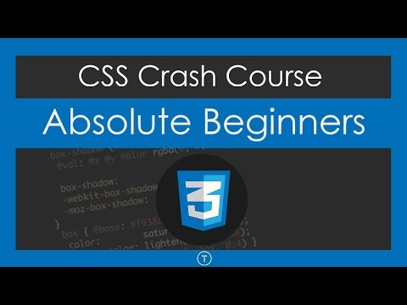](https://www.youtube.com/watch?v=yfoY53QXEnI)

Accessed on 21/09/2022

3.[W3Schools Tryit Editor](https://www.w3schools.com/css/tryit.asp?filename=trycss_align_pos)

Accessed on 22/09/2022